Grade 7 Accelerated · Unit 4 · Assessment  Solving Problems with Rational Numbers  34 points · two periods; students continue the same paper ANSWER KEY | Name  Date  Period

Show your work. Circle your final answer.
This assessment runs over two class periods. Stop when the period ends; you will continue from where you stopped.
If an earlier part is wrong, a later part still earns its point when the right operation is applied to your own earlier answer — but only if that work is on the page.
1. Operations in Scientific Notation 12 points
1. Add or subtract. Write each answer in scientific notation.
a. 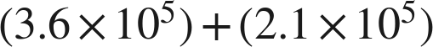 1 pt
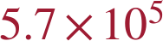
Same power: add the coefficients.
b. 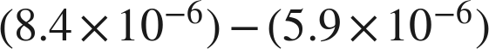 1 pt
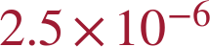
c. 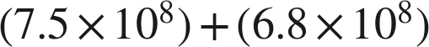 1 pt

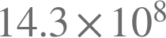 is the value; 14.3 is not less than 10, so it is not the answer.
d. 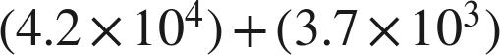 1 pt

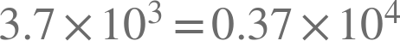.
Scoring: a 1 · b 1 · c 1 · d 1 = 4 points.

2. Multiply or divide. Write each answer in scientific notation.
a. 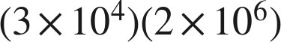 1 pt

b. 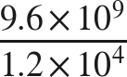 1 pt

c. 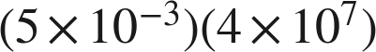 1 pt

 is not finished.
d. 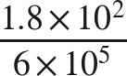 1 pt
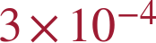
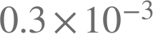 is not finished either.
Scoring: a 1 · b 1 · c 1 · d 1 = 4 points.

3. Which is the value of 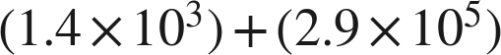 ? 1 pt
○ A. 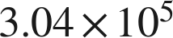
○ B. 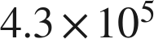
● C. 
○ D. 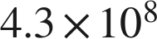
C
Scoring: 1 point.

4. Select ALL of the expressions whose value is . 1 pt
☒ A. 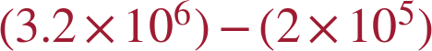
☐ B. 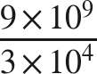
☒ C. 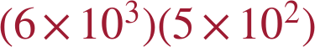
☒ D. 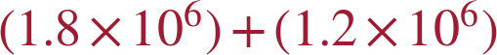
☐ E. 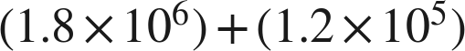
☒ F. 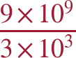
A, C, D and F
C gives 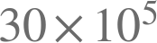, which is 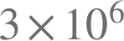 once it is finished. All four correct and nothing else for the point.
Scoring: 1 point.

5. Kendra writes . Name the two mistakes she made, and give the correct sum. 1 pt
She added the coefficients without first writing both numbers over the same power of ten, and she added the exponents. The correct sum is 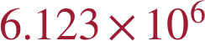.
Both mistakes must be named for the point; one of the two is half the item. .
Scoring: 1 point.

6. A number is multiplied by 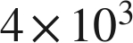 and the product is 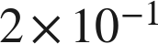. What was the number? Write your answer in scientific notation. 1 pt
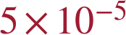
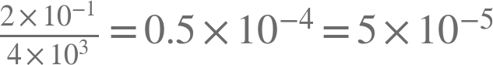. Working a product backwards across a sign change appears on no review and in no question bank; the point is for the finished form, so 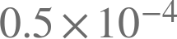 alone does not earn it. TRANSFER ITEM — not on the practice test. Same benchmark, a surface nobody rehearsed.
Scoring: 1 point.

2. Real-World Problems and Significant Digits 9 points
7. Give the number of significant digits in each measurement.
a. 3,080 grams 1 pt
3
The middle zero counts; the trailing zero does not, with no decimal point written.
b. 0.00405 meters 1 pt
3
Leading zeros never count; the zero between the 4 and the 5 does.
c. 12.500 seconds 1 pt
5
A decimal point is written, so both trailing zeros count.
Scoring: a 1 · b 1 · c 1 = 3 points.

8. Solve. Report each answer with the correct number of significant digits.
a. A rectangular plate measures  mm by 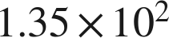 mm. Find its area. 1 pt
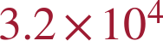 square millimeters
32,400 exactly; 2 significant digits and 3, so the answer keeps 2.
b. A vehicle travels 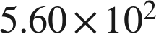 km in 8.0 hours. Find its average speed. 1 pt
 km/h
Exactly 70; two significant digits are justified, so the zero is written.
Scoring: a 1 · b 1 = 2 points.

9. Solve. Report each answer with the correct precision.
a. Two lengths are measured: 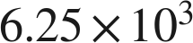 mm and 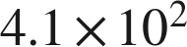 mm. Find their sum. 1 pt
 mm
6,250 and 410 both stop at the tens place, so the sum, 6,660, does too — and its last significant digit is the second 6, in the tens place. Writing 6.660 would claim the ones place, which neither measurement supports.
b. Two masses are measured: 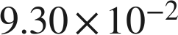 g and 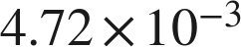 g. Find their difference. 1 pt
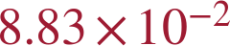 g
0.08828 exactly; 0.0930 stops at the ten-thousandths, so the answer stops there.
Scoring: a 1 · b 1 = 2 points.

10. Jonah adds two measured lengths, 4,560 m and 3.2 m, and says the sum must be written with two significant digits, as 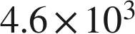 m. Explain why he is wrong, and give the correct sum. 1 pt
The counting rule is for products and quotients. A sum stops at the leftmost place where either measurement's last digit sits: 4,560 stops at the tens (its trailing zero is not significant) and 3.2 stops at the tenths, so the sum, 4,563.2, stops at the tens. It is 4,560 m, or  m.
The point needs the rule named AND the correct sum. Saying only 'he used the wrong rule' does not earn it.
Scoring: 1 point.

11. A rectangle's sides are measured as 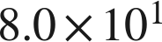 cm and 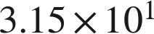 cm. Which is the area, in scientific notation with the correct number of significant digits? 1 pt
● A.  cm²
○ B. 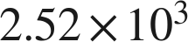 cm²
○ C. 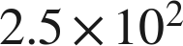 cm²
○ D. 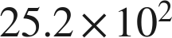 cm²
A
Scoring: 1 point.

3. The Order of Operations with Exponents and Radicals 13 points
12. Evaluate each expression.
a. 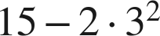 1 pt
−3
The power first, then the product, then the subtraction.
b. 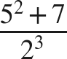 1 pt
4
32 over 8; the bar groups the whole numerator.
c. 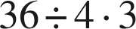 1 pt
27
One level, left to right: 9 · 3. Not 3.
d. 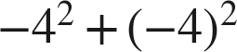 1 pt
0
−16 + 16. The parentheses decide what the exponent is attached to.
Scoring: a 1 · b 1 · c 1 · d 1 = 4 points.

13. Evaluate each expression.
a. 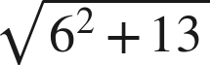 1 pt
7
Finish under the bar: 36 + 13 = 49.
b. 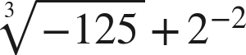 1 pt
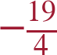
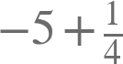.
c. 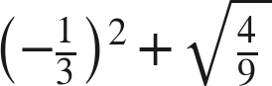 1 pt
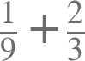.
Scoring: a 1 · b 1 · c 1 = 3 points.

14. A square patio of side 14 feet is sealed at 2.40 dollars a square foot, with a flat 85 dollars for delivery.
a. Write an expression for the total cost. 1 pt
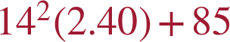
The rate multiplies the area; the flat fee does not. An expression that charges 85 on every square foot does not earn the point.
b. Find the total cost. 1 pt
555.40 dollars
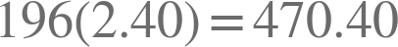, then 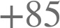.
Scoring: a 1 · b 1 = 2 points.

15. Which is the value of 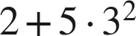 ? 1 pt
○ A. 32
● B. 47
○ C. 63
○ D. 289
B
Scoring: 1 point.

16. Select ALL of the expressions whose value is 6. 1 pt
☐ A. 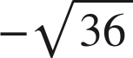
☒ B. 
☐ C. 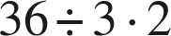
☒ D. 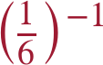
☒ E. 
☒ F. 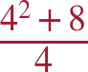
B, D, E and F
All four correct and nothing else for the point.
Scoring: 1 point.

17. Nadia writes . Explain why she is wrong, and give the correct value. 1 pt
The radical bar is a grouping symbol, so 25 + 144 is finished before the root is taken: 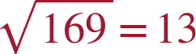. The root of a sum is not the sum of the roots.
The point needs the reason AND the value. '13' alone does not earn it, and neither does 'she added wrong'.
Scoring: 1 point.

18. A square tile has an area of 169 square inches. A second square tile has a side twice as long as the first. What is the area of the second tile? 1 pt
676 square inches
The side of the first is 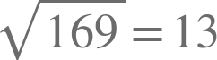, so the second has side 26 and area 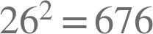. Doubling a side and asking for the new area appears on no review and in no question bank; a student who doubles the area and writes 338 has not gone through the side. TRANSFER ITEM — not on the practice test. Same benchmark, a surface nobody rehearsed.
Scoring: 1 point.

Score Tracker
34 points, one point per lettered part. Section 1 — 12 · Section 2 — 9 · Section 3 — 13
Benchmark | Questions | Possible | Earned
MA.8.NSO.1.5 | 1, 2, 3, 4, 5, 6 | 12
MA.8.NSO.1.6 | 7, 8, 9, 10, 11 | 9
MA.8.NSO.1.7 | 12, 13, 14, 15, 16, 17, 18 | 13
Total |  | 34

Follow-through (ruling 19). A later part is correct when the right operation is applied to the student's own earlier value. Look at what they wrote for the earlier part, do this part's operation to it, and tick if that is what they wrote. It applies only where the work is on the page.
Transfer items (ruling 18): questions 6 and 18. Neither surface appears on the review or in any question bank.

